Sidekick

Resolution Workflow

Version 1.0 – December 4, 2014

Contents

1. Resolution workflow diagram 2

2. Problem notification 3

3. Problem classification 4

3.1. Appliance Specific 5

3.2. Configuration 7

3.3. License/Account 7

3.4. Client Side 8

3.5. Service Infrastructure 9

4. Resolution according to role 10

4.1. Sidekick Application Key User (SAKU) 10

4.2. Consumer Care Support (CCS) 14

4.3. R&D/Factory 16

4.4. HCL Servicedesk 17

4.5. Resolver group Sidekick Support 18

# Resolution workflow diagram

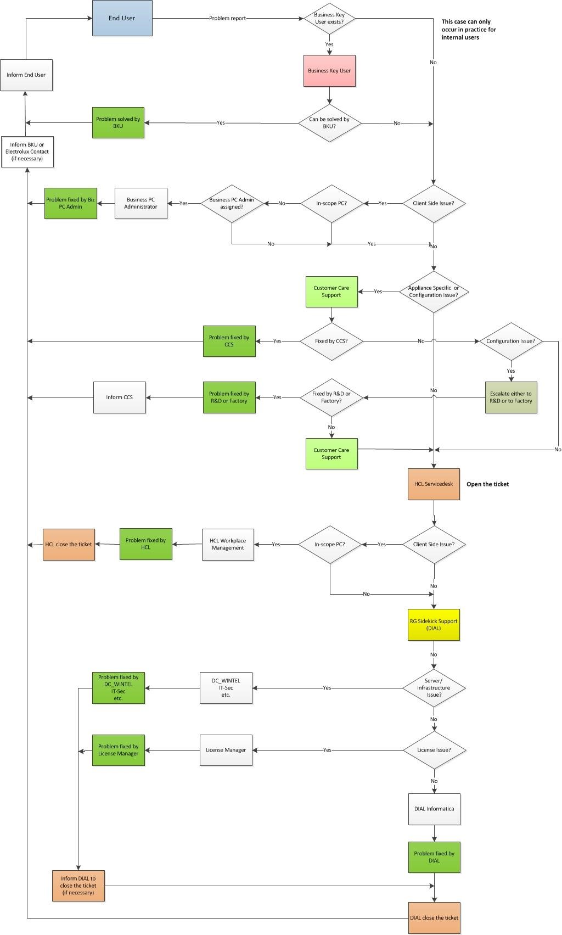

# Problem notification

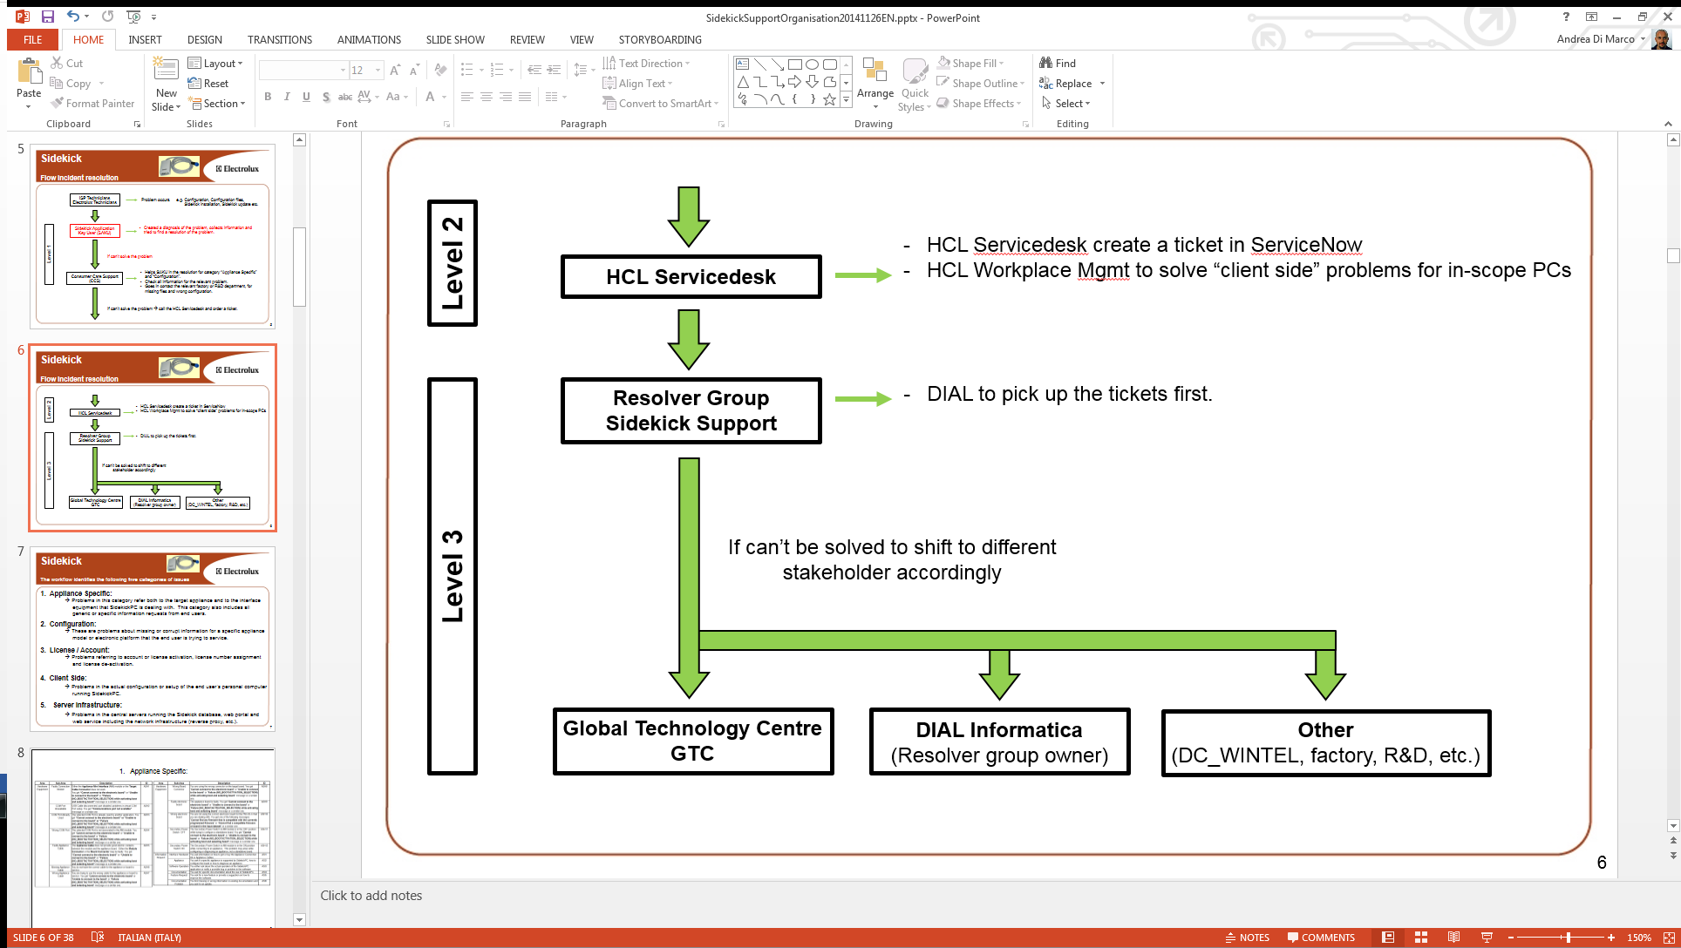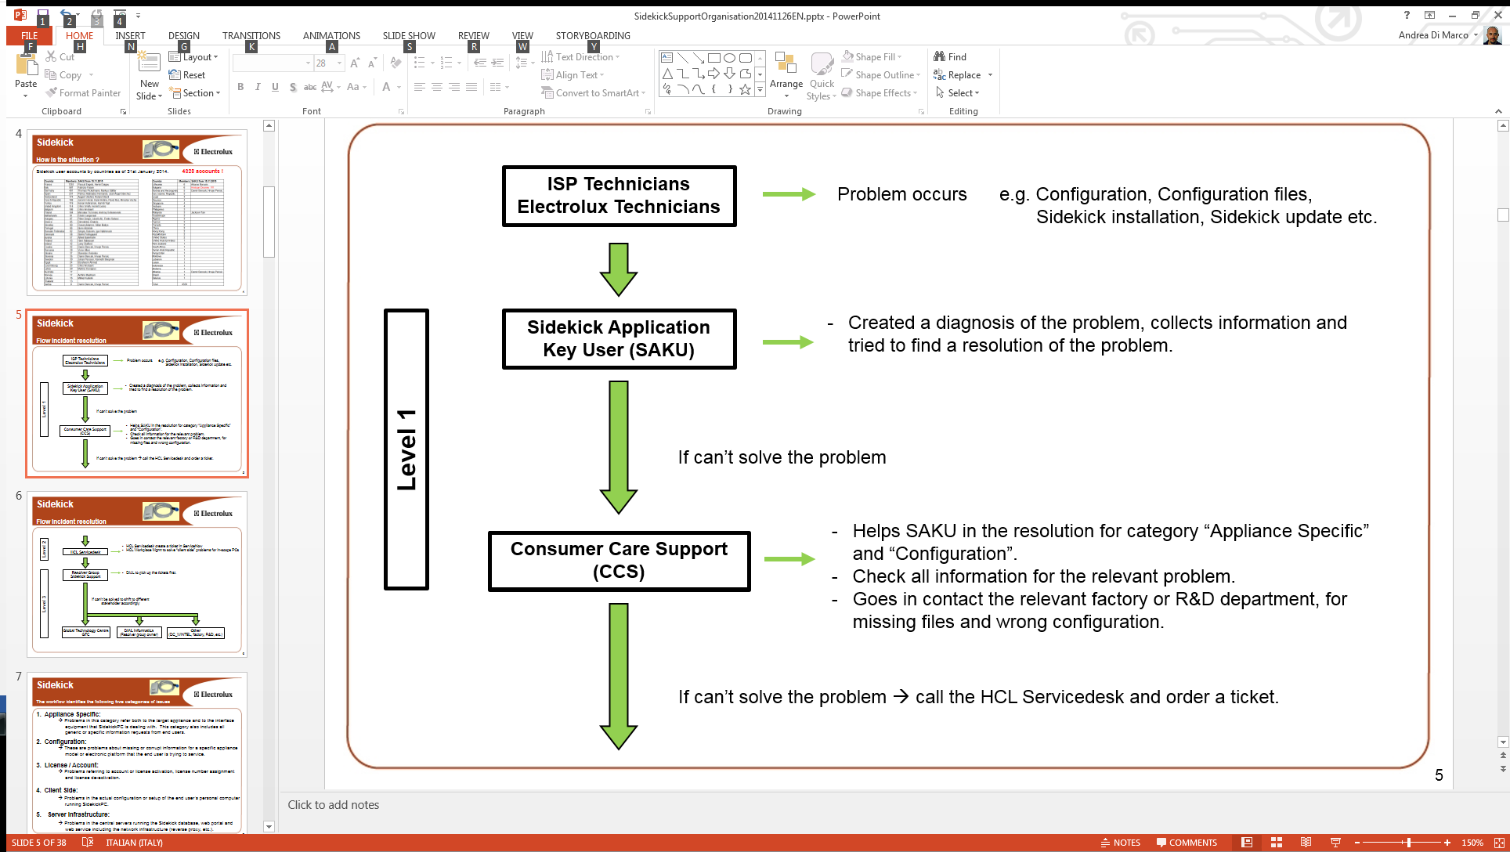

# Problem classification

The workflow identifies the following categories of issues:

1. **Appliance Specific: p**roblems in this category refer both to the target appliance and to the interface equipment that SidekickPC is dealing with. This category also includes all generic or specific information requests from end users.
2. **Configuration:** these are problems about missing or corrupt information for a specific appliance model or electronic platform that the end user is trying to service.
3. **License/Account:** problems referring to account or license activation, license number assignment and license de-activation.
4. **Client Side:** problems in the actual configuration or setup of the end user’s personal computer running SidekickPC.
5. **Server Infrastructure:** problems in the central servers running the Sidekick database, web portal and web service including the network infrastructure (reverse proxy , etc.).

The most critical category among the above ones is the “Server Infrastructure” since it affects many users at the same time.

The following table lists all possible problems classified by Category, Area and Sub-Area. Please note and ID identifies each type of problem by Category, Area and progressive index.

## Appliance Specific

|  |  |  |  |  |
| --- | --- | --- | --- | --- |
| **Category** | **Area** | **Sub-Area** | **Description** | **ID** |
| Appliance Specific | Hardware  Equipment  (see **AMI**  **Items** and  **Hardware**  **Interfaces** figures in  Figure 13) | Faulty Connection Module | Either the **Appliance Mini Interface** (AMI) module or the **Target Cable Connector** does not work.  You get “**Cannot connect to the electronic board**” or “**Unable to connect to the board**” or “**Failure (NO_BOOTACTIVATION_SELECTION) while activating boot and selecting board**” message or a similar one. | ASH1 |
| COM Port Unavailable | USB Cable disconnected, port disabled, problems in virtual COM Port setup.  You get “**Communications port not available**” message or a similar one. | ASH2 |
| COM Port Already Used | The selected COM Port is already used by another application.  You get “**Cannot connect to the electronic board**” or “**Unable to connect to the board**” or “**Failure (NO_BOOTACTIVATION_SELECTION) while activating boot and selecting board**” message or a similar one. | ASH3 |
| Wrong COM Port | The selected COM Port is not associated to the AMI module.  You get “**Cannot connect to the electronic board**” or “**Unable to connect to the board**” or “**Failure (NO_BOOTACTIVATION_SELECTION) while activating boot and selecting board**” message or a similar one. | ASH4 |
| Faulty Appliance Cable | The **Appliance Cable** does not provide good electric contacts between the module and the appliance board. Either the **Module Connecto**r or the **Board Connector** may be faulty. You get “**Cannot connect to the electronic board**” or “**Unable to connect to the board**” or “**Failure (NO_BOOTACTIVATION_SELECTION) while activating boot and selecting board**” message or a similar one. | ASH5 |
| Missing Appliance Cable | You do not have the correct cable for the appliance or board to service. | ASH6 |
| Wrong Appliance Cable | You are trying to use the wrong cable for the appliance or board to service.  You get “**Cannot connect to the electronic board**” or “**Unable to connect to the board**” or “**Failure (NO_BOOTACTIVATION_SELECTION) while activating boot and selecting board**” message or a similar one. | ASH7 |
| Wrong Board Connector | You are using the wrong connector on the target board.  You get “**Cannot connect to the electronic board**” or “**Unable to connect to the board**” or “**Failure (NO_BOOTACTIVATION_SELECTION) while activating boot and selecting board**” message or a similar one. | ASH8 |
| Faulty electronic board | The appliance board is faulty.  You get “**Cannot connect to the electronic board**” or “**Unable to connect to the board**” or “**Failure (NO_BOOTACTIVATION_SELECTION) while activating boot and selecting board**” message or a similar one. | ASH9 |
| Wrong electronic board | You are not using the correct electronic board for the PNC/ELC that you are dealing with. You get one of the following messages: “**Cannot find any firmware that is compatible with the currently programmed firmware**” or “**Cannot find a compatible firmware or board in the input dataset**” or a similar one. | ASH10 |
| Secondary Power Switch OFF | The Secondary Power Switch in AMI module is in the OFF position while trying to configure a standalone board.  You get “**Cannot connect to the electronic board**” or “**Unable to connect to the board**” or “**Failure (NO_BOOTACTIVATION_SELECTION) while activating boot and selecting board**” message or a similar one. | ASH11 |
| Secondary Power Switch ON | The Secondary Power Switch in AMI module is in the ON position while connecting to an appliance. This problem may arise while configuring or diagnosing an appliance, not a standalone board. | ASH12 |
| Information Request | Interface Hardware | You ask information on how to get or buy the Appliance Connection Kit or Appliance Cables. | ASI1 |
| Appliance | You ask if a specific appliance is supported by SidekickPC, how to configure the board or how to diagnose an appliance. | ASI2 |
| Software Operation | You either ask about the actual operation of the SidekickPC application or notify a possible bug or problem in the software. | ASI3 |
| Documentation | You ask for specific documentation about the use of SidekickPC. | ASI4 |
| Feature Request | You ask for a new feature or provide a suggestion on how to improve the software. | ASI5 |
| Documentation Problem | You find missing or wrong information in existing documentation and you ask for an update. | ASI6 |

## Configuration

|  |  |  |  |  |
| --- | --- | --- | --- | --- |
| **Category** | **Area** | **Sub-Area** | **Description** | **ID** |
| Configuration | Database | Missing PNC/ELC code | The specified PNC/ELC code is missing in the system.  You get “**The specified code does not exist**” message or a similar one. | CFGDB1 |
| Wrong configuration data | After configuring a board/appliance for a certain PNC/ELC code, the appliance does not work correctly. | CFGDB2 |
| Diagnostic Procedures | Incorrect Execution | Diagnostic procedures do not work as expected. | CFGP1 |
| Cannot Start | Cannot start diagnostic procedures on the target appliance because they are not supported by Sidekick for the corresponding electronic platform.  You get “**Service Data not found or the diagnostic procedure is not supported**” message or a similar one. | CFGP2 |

## License/Account

|  |  |  |  |  |
| --- | --- | --- | --- | --- |
| **Category** | **Area** | **Sub-Area** | **Description** | **ID** |
| License/  Account | Activation | Cannot Activate or Deactivate | You have problems while activating or deactivating the license.  You get “**cannot connect to activation web site**”, “**cannot access web site (maybe behind firewall**” or a similar message. | LAA1 |
| Code Already Used | You have problems while activating the license. You get “**license number already used**” or a similar message. | LAA2 |
| Invalid License Number | You have problems while activating or deactivating the license.  You get “**invalid license number**” or a similar message. | LAA3 |
| Missing License Code | You do not know which license number to specify for the activation of the software. | LAA4 |
| Login | Missing Account | You do not have an internet Sidekick account the local database update or for accessing the web portal. | LAL1 |
| Bad User Name | You specify the wrong user name for the local database update or for accessing the web portal. In this case you get an “**Account not found**” or similar message. | LAL2 |
| Bad Password | You specify the wrong password for the local database update or for accessing the web portal. In this case you get an “**Account not valid**” or similar message. | LAL3 |
| Account Locked Out | Your internet Sidekick account is locked out because of too many login attempts with wrong password.  In this case you get a “**Your account has been locked**” or similar message. | LAL4 |

## Client Side

|  |  |  |  |  |
| --- | --- | --- | --- | --- |
| **Category** | **Area** | **Sub-Area** | **Description** | **ID** |
| Client Side | Software Setup | USB Driver Issues | You have problems while installing the USB Drivers for the Appliance Mini Interface. | CSSS1 |
| SQL Server Setup | The installation script fails during the setup of the local SQL Server Express instance. | CSSS2 |
| Other Setup | The installation script fails during the setup of support software packages except the local SQL Server Express instance. | CSSS3 |
| Missing Rights | You install the software without the required access rights to your PC. | CSSS4 |
| Software Update | Auto Update Failure | The automatic update procedure failed. SidekickPC stopped working correctly after the auto update. | CSSU1 |
| Manual Update Failure | The manual update procedure failed.  SidekickPC stopped working correctly after the manual update. | CSSU2 |
| Software Operation | Unexpected Behavior | You notice an unexpected behavior in SidekickPC. | CSSO1 |
| Function Not Available | You cannot access one or more functions in SidekickPC and you cannot explain why. | CSSO2 |
| Database Update | SQL Login Failure | You get “**Database connection error: Login failed for ‘SidekickPCUser**’” or similar message. | CSDU1 |
| Wrong Update Parameters | You get “**Invalid Parameters. Check the local database section!**” or similar message. | CSDU2 |
| SQL Server Service Stopped | You get “**error: 40 - Could not open a connection to SQL Server**” or similar message. | CSDU3 |
| Wrong SQL Server Instance | You get “**error: 26 – Error Locating**  **Server/Instance Specified**” or similar message | CSDU4 |
| Wrong Database Name | You get “**Database connection error: Cannot open database**’” or similar message. | CSDU5 |
| Connection | You get “**Login failed for user**” or similar message. | CSDU6 |
| Insufficient Disk Space | You get “**Could not allocate a new page for database ‘SidekickPC’ because of insufficient disk space**” or similar message during the database update phase. | CSDU7 |
| Maximum DB Size Reached | You get “**Could not allocate a new page for database ‘SidekickPC’ because of insufficient disk space…Cannot fetch a row from OLE DB provider**” or similar message during the database update phase. | CSDU8 |
| Maximum No Update Time  Elapsed | You get “**Maximum no update time is expired. Please execute a full update.**” or similar message while executing an Incremental or PNC Update. | CSDU9 |
| Wrong Date in Local PC | You get “**WSE910: An error happened during the processing of a response message, and you can find the error in the inner exception. You can also find the response message in the Response property. Inner Exception Message: Incoming message does not meet security requirements**” or similar message. | CSDU10 |
| Generic Failure | You get a database-related error not classified in the above definitions. | CSDU11 |
| Internet | Remote Web Service URL | You get “**The request failed with HTTP status 404: Not Found**”, “**Remote web service connection error**” or similar message- | CSI1 |
| Software Auto Update URL | You get “**The remote server returned an error: (404) Not Found**”, “**Software auto update URL connection error**”, “**does not match the end tag** “or similar message- | CSI2 |
| Slow Connection | The download of new data from the server is very slow and/or you get the “**The underlying connection was closed**” or similar message. | CSI3 |
| Antivirus / Firewall | Antivirus or firewall settings prevent the successful execution of the update. | CSI4 |

## Service Infrastructure

|  |  |  |  |  |
| --- | --- | --- | --- | --- |
| **Category** | **Area** | **Sub-Area** | **Description** | **ID** |
| Server  Infrastructure | Database | Database Down | You get “**WSE910: An error happened during the processing of a response message, and you can find the error in the inner exception. You can also find the response message in the Response property. Inner Exception Message: Incoming message does not meet security requirements**” or similar message. | SID1 |
| SSIS Problems | The automatic execution of the SSIS package for Sidekick fails and, as a consequence, new codes and data from R&D/Factories are not copied to the Sidekick system. One possible cause is the configuration of the “SQL Proxy” account. | SID2 |
| Web Server | Web Service | The web service is not accessible from a browser: [http://sidekick.int.electrolux.com/SidekickServ ice2/Sidekickservice.asmx](http://sidekick.int.electrolux.com/SidekickService2/Sidekickservice.asmx) | SIWS1 |
| Web Portal | The web service is not accessible from a browser: [http://sidekick.int.electrolux.com/SidekickPort al/](http://sidekick.int.electrolux.com/SidekickPortal/) | SIWS2 |
| Load Balancer | Intermittent problems while accessing the web service from a browser. | SIWS3 |
| Unexpected Behavior | You notice an unexpected behavior in the web portal or web service. | SIWS4 |
| Function Not Available | You cannot access one or more functions in the web portal and you cannot explain why. | SIWS5 |
| Generic Failure | You get a web-related error not classified in the above definitions. | SIWS6 |
| Network | Access Down | Internet URL of web service and/or web portal is not accessible from a browser: [http://sidekick.electrolux.com/SidekickService](http://sidekick.electrolux.com/SidekickService2/Sidekickservice.asmx)  [2/Sidekickservice.asmx](http://sidekick.electrolux.com/SidekickService2/Sidekickservice.asmx)  <http://sidekick.electrolux.com/SidekickPortal/> | SIN1 |
| Access Slow | Upload and/or download speed is very slow from of web service and/or web portal. This problem affects all users. | SIN2 |

# Resolution according to role

## Sidekick Application Key User (SAKU)

**The Sidekick Application Key User (SAKU) is almost always the first immediate contact with the end user having troubles with SidekickPC.**

The SAKU should first of all collect the following information from the user:

1. Report the name of end user (if necessary a phone contact/email contact/location) and the User Name of the Sidekick internet account
2. Identify the end user machine (OS version, available RAM, etc...) for example by means of the **System** applet in **Control Panel**:

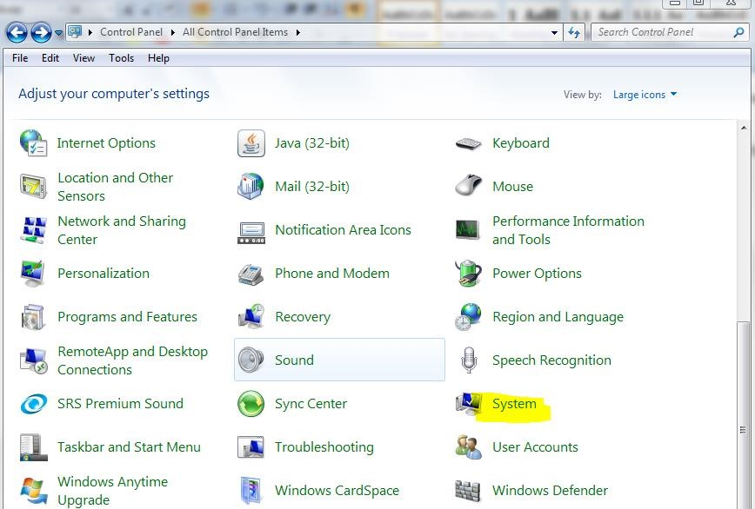

System applet in Control Panel

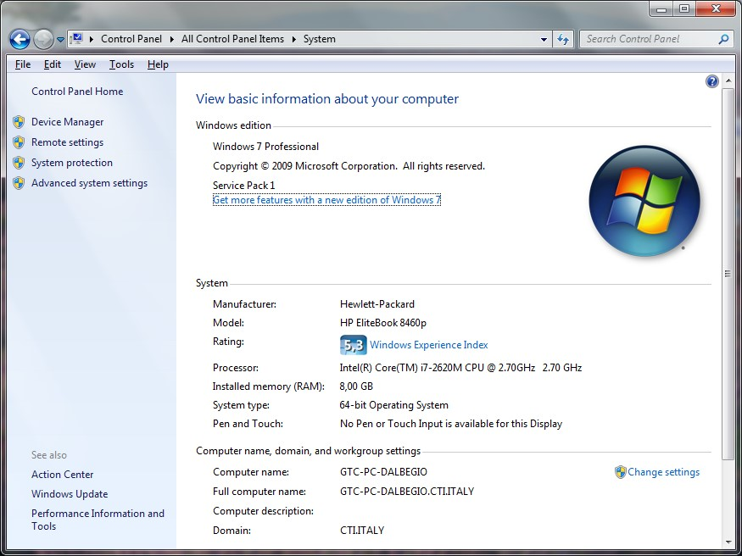

System information

1. Identify SidekickPC version installed on the end user machine. You should ask the user to report the information in the **Help >> About** dialog box in SidekickPC:

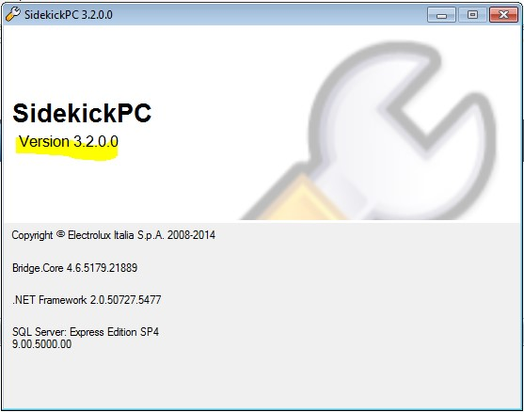

SidekickPC information in About dialog box

1. Does the user get an error message? If yes what is the Error message? The user should provide the SAKU all relevant details including the SidekickPC screenshot that shows what is the actual error message or problem.
2. Comprehensive problem description: specify what the end user is trying to do.
3. Supply all steps than can regenerate the error, if possible.

The SAKU should determine if the problem that the end user is facing is already known. In this case the SAKU should guide the end user towards the steps for the resolution of the problem.

**Here you can find the suggested resolution steps for problems that you can typically solve at this stage:**

1. Verify if the user is really using the latest version of the SidekickPC software. It is likely that the latest version of the application fixes known problems and supports new electronic platforms. If you think that the latest version of SidekickPC may solve the problem, ask the user to update the software.
2. Try to understand if this is an **Appliance Specific** problem from the description provided by the user or from the error message. Please refer to the table in Problem Classification. If there is evidence that this is an Appliance Specific - Hardware problem, try solving the problem on your own.

* Verify the correct connection of the equipment (cable, connectors) to the electronic board.
* Verify that the end user is applying the correct PNC/ELC and spare board.
* Verify that the end user has ordered the right spare code and that the spare parts warehouse has delivered the correct board. The following information is relevant and the board configuration data section in the web portal could help solve the issue. - Identify the board or appliance:
* PNC/ELC + Model
* Spare part code ordered
* Spare part code delivered
* Information on the printed label of the electronic board or box delivered
* Verify that there is a match between the board delivered to the end user and the spare board code information associated to the PNC code that the user wants to configure. You can use for example the **Spare Board Information** dialog box in SidekickPC that shows spare board codes from the Technical Documentation System (TDS) database. You should use one of the listed spare part codes for the specified PNC/ELC:

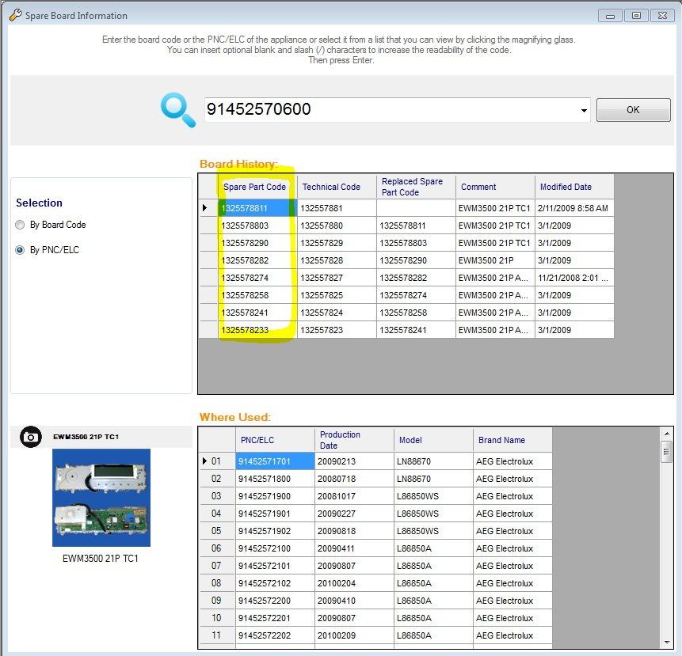

Spare Board Information dialog box

1. If the user is just asking for information (**Appliance Specific – Information Request** ASI1 to ASI4 issues), you should provide the requested information if possible. Otherwise you should escalate to **Consumer Care Support**.
2. If the user is asking for a change or correction (**Appliance Specific – Information Request** ASI5 and ASI6 issues), you should escalate to **Consumer Care Support**.
3. If the user is getting ”**The specified code does not exist**” (**Configuration** issue: **CFGDB1**) error message, check if the specified PNC/ELC is really missing by entering the [Board Configuration Data](http://sidekick.electrolux.com/SidekickPortal/PortalManagement/BoardConfigurationData.aspx) page in the Sidekick Web Portal. If the code exists, ask the user to execute an update. Otherwise escalate the issue to the next level. Figures below show two examples of data found and not found in the Sidekick Web Portal.

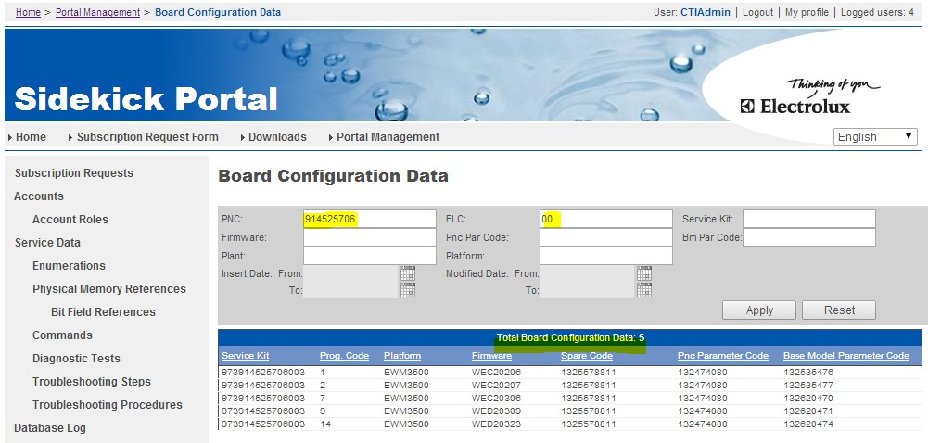

Board Configuration Data in web portal (PNC/ELC code exists)

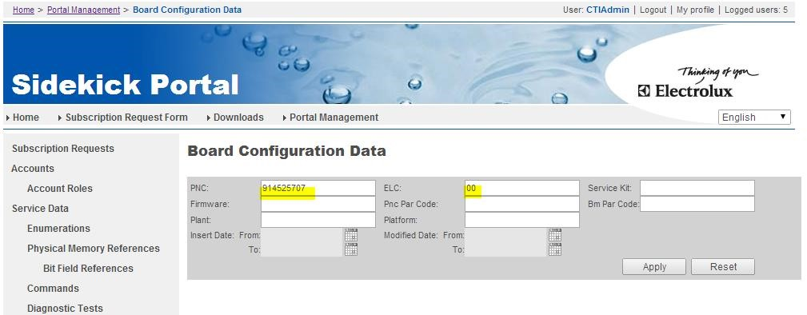

Board Configuration Data in web portal (PNC/ELC code does not exist)

1. Check if this is a Client Side problem from the description provided by the user or from the error message.

Please refer to the table in Problem Classification. If there is evidence that the problem of the user falls into this category you should verify if the PC of the user is IN-SCOPE or not.

* **If the PC is IN-SCOPE** you should escalate the issue to HCL Servicedesk.
* **If the PC is OUT-OF-SCOPE** you should check if there is a Business PC Administrator for the user, and ask him/her for the resolution of the problem. In case there is no designed administrator, like in the case of Italian service contractors, you should escalate the issue to HCL Servicedesk.

1. Verify if this is a **known problem** and if there is an application note about it with a workaround. Electrolux publishes knowledge base and application notes in the [Downloads](http://sidekick.electrolux.com/SidekickPortal/UsersReservedArea/Downloads.aspx) page of the Sidekick Web Portal. All Business Key Users are included in a mailing list for notifications about news and important information about Sidekick. All Sidekick documentation is provided in English only. It is up to each local service organization to make the translations of the relevant documents when this is really necessary.

If you cannot solve the user’s issue on your own with the above steps, you should escalate to the next level by providing all the information about the problem that you have collected during the Initial Problem Description phase, together with information about your own investigation steps, if any.

Within the next few months, all SAKUs will be License Managers for their own area and they will be able to address most License/Account issues on their own.

## Consumer Care Support (CCS)

Consumer Care Support is in charge of dealing with Appliance Specific and Configuration issues.

Upon receiving a request of support, you should check if all relevant information about the problem is already available. You should turn to the end user to ask for any piece of information that you need to better address the problem.

The resolution steps of CCS are in part identical to the steps of the SAKU. It may happen that the SAKU does not have all the knowledge and experience to address problems on his/her own.

1. Verify if the user is really using the latest version of the SidekickPC software. It is likely that the latest version of the application fixes known problems and supports new electronic platforms. If you think that the latest version of SidekickPC may solve the problem, ask the user to update the software.
2. Try to understand if this is an Appliance Specific problem from the description provided by the user or from the error message. Please refer to the table in Problem Classification. If there is evidence that this is an Appliance Specific - Hardware problem, try solving the problem on your own.

* Verify the correct connection of the equipment (cable, connectors) to the electronic board.
* Verify that the end user is applying the correct PNC/ELC and spare board.
* Verify that the end user has ordered the right spare code and that the spare parts warehouse has delivered the correct board. The following information is relevant and the board configuration data section in the web portal could help solve the issue.
* Identify the board or appliance:
* PNC/ELC + Model o Spare part code ordered o Spare part code delivered
* Information on the printed label of the electronic board or box delivered
* Verify that there is a match between the board delivered to the end user and the spare board code information associated to the PNC code that the user wants to configure. You can use for example the Spare Board Information dialog box in SidekickPC that shows spare board codes from the Technical Documentation System (TDS) database. You should use one of the listed spare part codes for the specified PNC/ELC.

1. If the user is just asking for information (**Appliance Specific – Information Request** ASI1 to ASI4 issues), you should provide the requested information if possible. Otherwise you should escalate to **RG Sidekick Support**.
2. If the user is asking for a change or correction (**Appliance Specific – Information Request** ASI5 and ASI6 issues), you should check if the request is really relevant and if you can fix the documentation on your own. In case you cannot close the problem on your own you should escalate to **RG Sidekick Support**.
3. If the user is getting “**The specified code does not exist**” (**Configuration** issue: **CFGDB1**) error message, check if the specified PNC/ELC is really missing by entering the [Board Configuration Data](http://sidekick.electrolux.com/SidekickPortal/PortalManagement/BoardConfigurationData.aspx) page in the Sidekick Web Portal. If the code exists, ask the user to execute an update. Otherwise escalate the issue to the corresponding **R&D/Factory** and ask them to insert the specified PNC/ELC code in the system.
4. If the user complains that the appliance is not working properly after the configuration of the board (**Configuration** issue: **CFGDB2**) you should ask him to look into the **Programming Log** dialog box of SidekickPC and check the actual **PNC/ELC, Prog**, and **Service Kit Code** that was used for the configuration of the board as shown in the following figure:

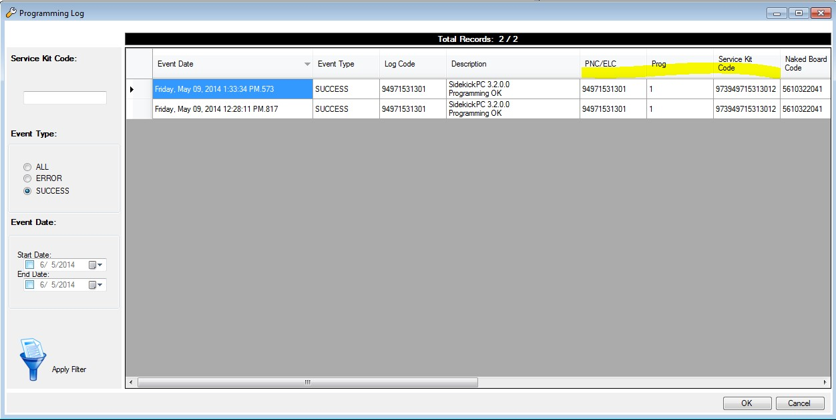

Record Information from Programming Log

After getting from the user this information, you should escalate the issue to the corresponding R&D/Factory, describe the problem and provide PNC/ELC/Prog and Service Kit Code.

1. Verify if this is a **known problem** and if there is an application note about it with a workaround. Electrolux publishes knowledge base and application notes in the [Downloads](http://sidekick.electrolux.com/SidekickPortal/UsersReservedArea/Downloads.aspx) page of the Sidekick Web Portal.

In case the problem does not fall within the above ones, or you cannot solve the issue on your own, you should escalate the ticket to **HCL Servicedesk**.

## R&D/Factory

**R&D/Factory people are only in charge of dealing with Configuration issues and in most cases they get requests from Consumer Care Support. It may happen, sporadically, that SAKUs directly ask for support about Configuration problems. In this case, however, the problem is not tracked in ServiceNow.**

It is important to highlight that actual resolution steps depend on the product line, since each of them uses different tools, rules and approaches for providing the necessary information to the Sidekick system. At any rate, the following general guidelines are valid:

1. If the user is getting “**The specified code does not exist**” (Configuration issue: **CFGDB1**) error message, you should insert the specified PNC/ELC records in the BOM100 table of the corresponding local factory copy of the **Product Software Storage** (PSS) database. You should use the insertion tools of your product line. If for any reason this is not possible because of missing configuration data and files from R&D department, you should insert such information before adding the BOM100 record.
2. If the end user complains that the appliance is not working properly after the configuration of the board (**Configuration** issue: **CFGDB2**), you should check the actual **PNC/ELC, Prog**, and **Service Kit Code** that was used for the configuration of the board (this information comes from **Consumer Care Support**). You should verify if the correct firmware and configuration files have been associated to the specified PNC/ELC. To check the actual configuration recipe programmed by SidekickPC you can use the [Board Configuration Data](http://sidekick.electrolux.com/SidekickPortal/PortalManagement/BoardConfigurationData.aspx) page in the Sidekick Web Portal and select the record of the actual **PNC/ELC, Prog**, and **Service Kit Code**:

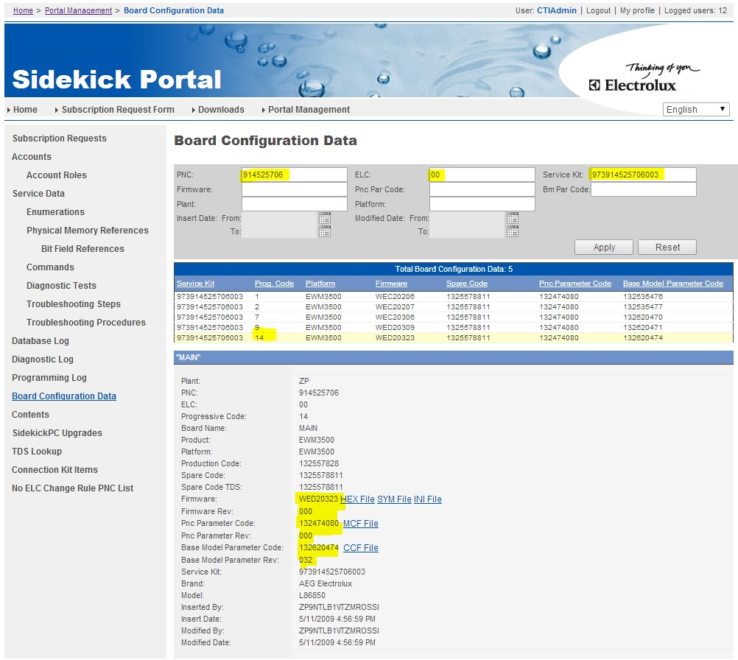

Configuration recipe details (firmware and parameters)

* In case the firmware and/or configuration codes are not correct, you should fix the issue by adding a new record (new **Prog**) in the BOM100 table of the PSS database.
* In case the firmware and/or configuration codes look correct, you should extract the configuration files from the PSS database and investigate why they are corrupt and apply necessary fixes. You can download these files from the [Board Configuration Data](http://sidekick.electrolux.com/SidekickPortal/PortalManagement/BoardConfigurationData.aspx) page by using the links at the right side of the **Firmware, PNC Parameter Code** and **Base Model Parameter Code** (see the previous figure).

If you cannot solve the issue on your own, you should turn to Consumer Care Support in order to escalate the issue.

## HCL Servicedesk

**All issues that reach the service desk should be tracked within the ServiceNow system. Typically the service desk operator should check if the following information has been provided by the people asking for support according to the question template in the following section.**

Standard question template for HCL

You should check if all information collected during the Initial Problem Description by the SAKU is really available, otherwise you should turn to the end user to collect all missing information in order to speed up further investigation steps.

User and problem information that you should collect is:

* Name of end user affected by the problem (if necessary a phone contact/email contact/location) and the User Name of the Sidekick internet account.
* End user machine (OS version, available RAM, etc...).
* SidekickPC version that the affected user is using.
* Does the user get an error message? If yes what is the Error message? The user should provide the SAKU all relevant details including the SidekickPC screenshot that shows what is the actual error message or problem.
* Comprehensive problem description: specify what the end user is trying to do.
* Supply all steps than can regenerate the error, if possible.

The next paragraph describes the resolution steps for the service desk in case of **Option 1** for the resolution workflow.

HCL Servicedesk should at first identify which is the actual Category of problem that the user is facing.

1. Check if this is a Client Side problem from the description provided by the user or from the error message. Please refer to the table in Problem Classification. If there is evidence that the problem of the user falls into this category you should verify if the PC of the user is IN-SCOPE or not.

* **If the PC is IN-SCOPE** you should ask HCL Workplace Management to fix the problem.
* **If the PC is OUT-OF-SCOPE** you should escalate the issue to RG Sidekick Support.

1. Verify if this is a known problem documented within the Knowledge Base of ServiceNow and if there is an application note about it with a workaround. In this case you should suggest the user to execute the documented steps for the resolution of the problem.

In case the problem does not fall within the above ones, or you cannot solve the issue on your own, you should escalate the ticket to RG Sidekick Support.

## Resolver group Sidekick Support

**RG Sidekick Support is the final responsible for the resolution of Sidekick problems that were not closed at the previous support levels.**

RG Sidekick Support Resolution Steps:

1. Identify the problem from the user, which actual category is it.
2. Check if this is a **Server Infrastructure** problem from the description provided by the user or from the error message. Please refer to the table in Problem Classification. If there is evidence that the problem of the user falls into this category you should escalate the issue to the relevant **Electrolux IT group** (**DC_WINTEL, Security, Networking**, etc.). These problems have always the highest priority since they typically affect many Sidekick users.
3. Check if this is a License problem from the description provided by the user or from the error message. Please refer to the table in Problem Classification. If there is evidence that the problem of the user falls into this category you should perform all the actions to fix it.
4. You should perform all the actions to fix also all other problems that reach this level of support.

You should turn to Consumer Care Support, Global Technology Center, and Documentation Team or to any other Electrolux department, in case you need specific support to solve the problem. When the problem is fixed you should close the ticket in ServiceNow.